BCPS GUEST WIFI
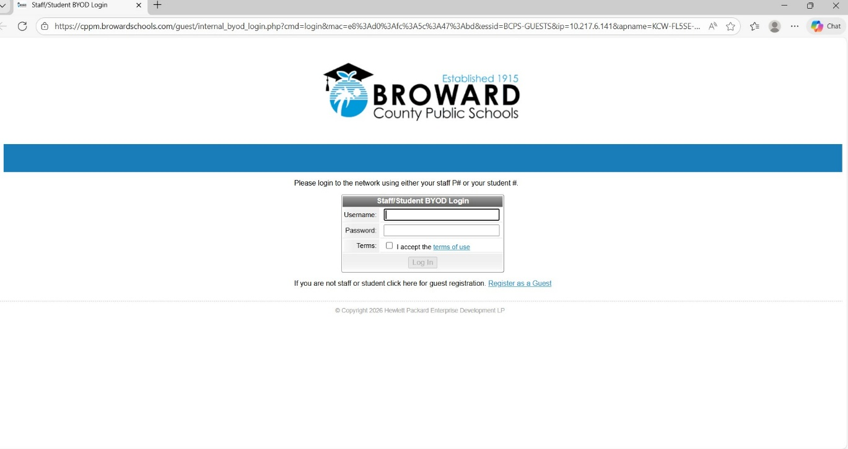
- Select BCPS Guest from computer WIFI options (browser page opens to this screen)
- CLICK: “Register as a Guest”
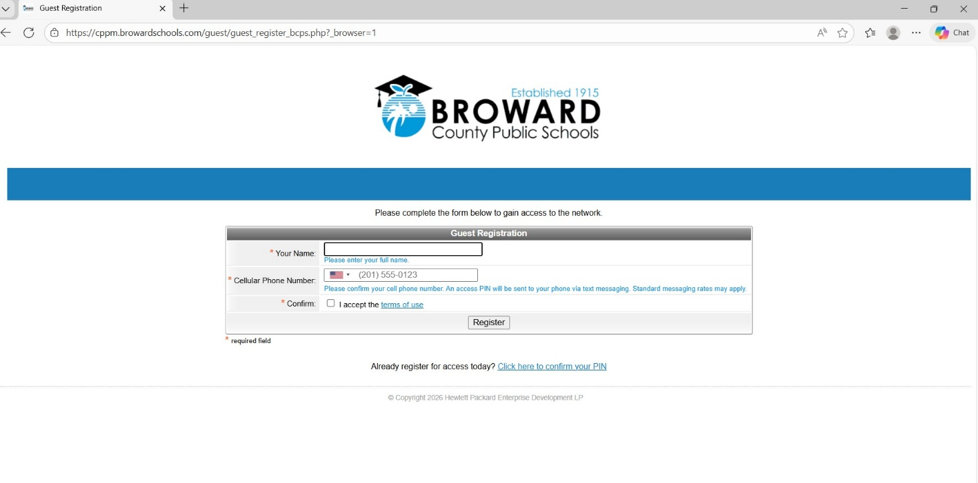
3. Type “Your Name”

4. Type your “Cell Phone Number”

5. Click “Confirm, I accept the terms of use”

6. Click “Register”
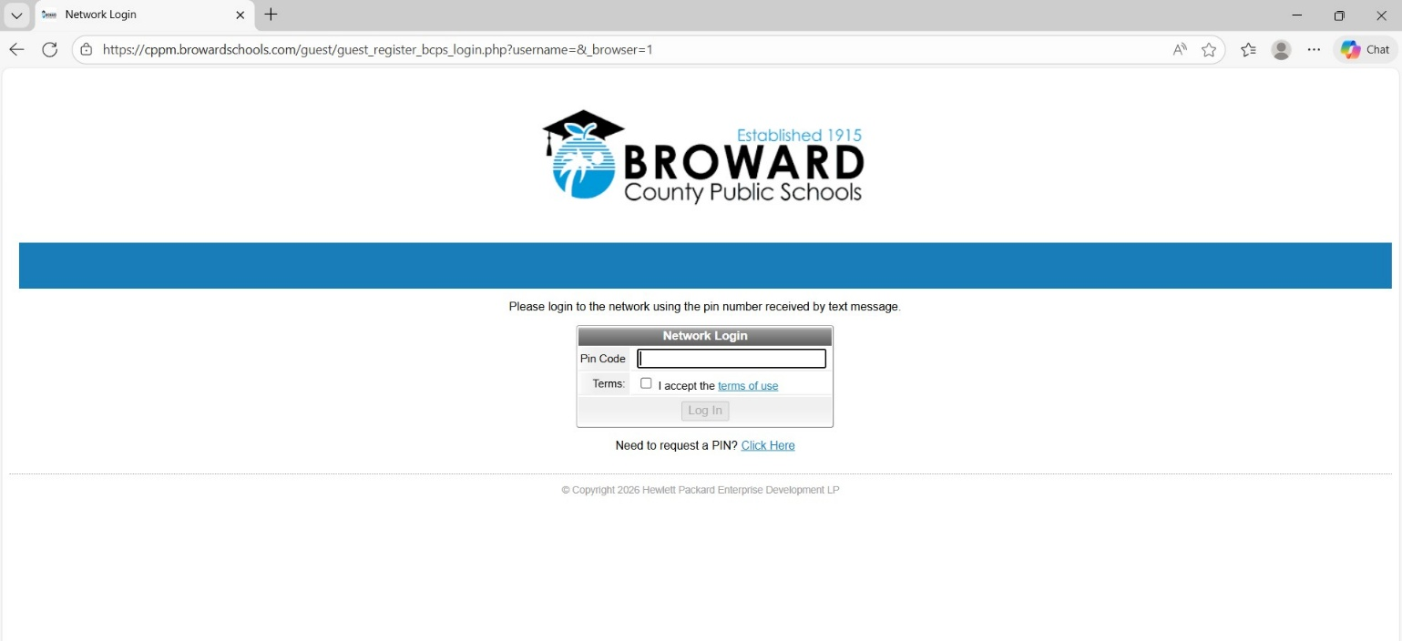
7. Check your cell phone for a Pin Code to enter
8. Click the “Terms, I accept the terms of use”
9. Click “Log In”

